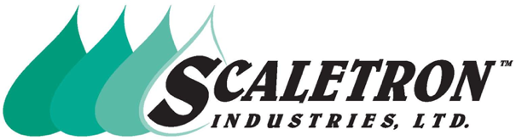
Technical Assistance: 800-257-5911 or 215-766-2670
Email: info@scaletronscales.com
Website: www.scaletronscales.com/downloads

TYPICAL SPECIFICATION FOR MODEL 3000LB™ TON CYLINDER LIFTING BAR

Quantity: A quantity of ______ Ton Cylinder Lifting Bar(s) shall be provided for securely lifting ton cylinders and containers.

Construction: The lifting bar must be constructed from rugged, 2" x 6" x 1/4" steel plate with reinforced pivot points. Heavy-duty hooks must be cut from 1" steel plate and fold inside of body for transport. Bar shall have a lifting bail made of 1" round steel stock and two fork lift carry points. Lifting bar must be protected by a corrosion resistant coating. Coating system shall consist of a zinc oxide primer and dry powder epoxy that is resistant to abrasion, chemicals, moisture and UV light.

Warranty: Lifting bar shall carry a full five (5) year factory warranty. “Limited” warranties shall not be accepted.

Lifting bar shall be a Model 3000LB as manufactured by Scaletron Industries Ltd., Plumsteadville, PA.

Part Number: 3000LB

Scaletron™ Industries, Ltd. Toll Free: 1-800-257-5911 (USA & Canada)
Bedminster Industrial Park Phone: (+1) 215-766-2670 (International)
53 Apple Tree Lane Fax: (+1) 215-766-2672
P.O. Box 365 E-mail: info@scaletronscales.com
Plumsteadville, PA 18949 USA Website: www.scaletronscales.com

Page 1 of 1

