Bedminster Industrial Park
53 Appletree Lane P.O. Box 365
Plumsteadville, PA 18949 USA

Toll Free: 1-800-257-5911 (USA & Canada)
Phone: (+1) 215-766-2670 (International)
Fax: (+1) 215-766-2672
E-mail: info@scaletronscales.com
Website: www.scaletronscales.com

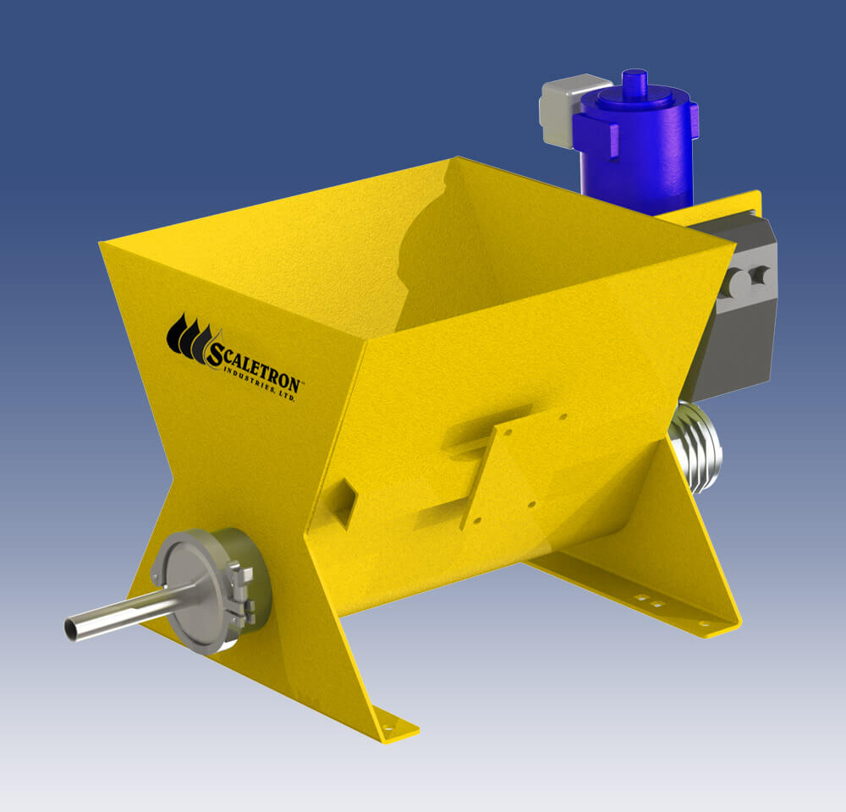

TYPICAL SPECIFICATION FOR MODEL VMF-90C
ECONOMICAL VOLUMETRIC SCREW FEEDER

Page 1 of 3

GENERAL FEATURES

Overview: Volumetric screw feeder shall be a Model VMF-90C as manufactured by Scaletron Industries Ltd., Plumsteadville, PA. Feeder must be a rugged, automatic metering screw feeder that is specifically designed for dispensing dry powdered or pelletized materials into a secondary process.
Operation: The feeder shall employ a heavy duty, concentric material conditioning overwind auger metering mechanism that produces uniform product density for accurate and continuous material feed without flooding, bridging or voids.

Feed Rate: The feed rate shall be ____________ (0.13 to 1.27) cubic feet per hour.

Accuracy: The feeder shall have a metering accuracy of ± 1% of volume and ± 3% by weight.

Environment: Feeder must operate with an ambient temperature limit of 10°C - 40°C.

Power: Power requirement shall be 115/230 VAC, 50-60 Hz, 4 Amps.

CONSTRUCTION

Materials of Construction: To provide reliable operation, feeder shall feature rugged, carbon steel construction with a corrosion resistant zinc oxide primed, dry powder epoxy coating. Minimum sheet metal thickness shall be 12 gauge (.105) and 7 gauge (.188) and all welds shall be continuous TIG. All chemical contact areas of the feeder including the auger, drive shafts, seal assembly, discharge cylinder and piping shall be constructed of stainless steel; the seals shall be synthetic.

HOPPER

Capacity: The feeder shall be supplied with a built-in, ______________ (304 or 316) stainless steel gravity fed hopper with a minimum of ________________ (1.5) cubic feet of storage capacity. A hopper extension shall be included to provide an additional ________________ cubic feet of storage capacity.

Features: Hopper shall have a 4” auger opening with sanitary flange for quick auger tube removal and a maintenance access/clean-out hatch. Hopper shall have mount for an optional vibratory agitator to ensure smooth flow of powder, an integrated load cell attachment point plus a flange for the attachment of hopper extensions, delumpers, bag loaders, etc.

Options: A hopper lid must be supplied. Lid type shall be (check one):

o Lift-off with handle. o Hinged with handle. o Clamp-on lid. o Adapter lid.

Page 2 of 3

AUGER

Type: Feeder shall employ a heavy-duty, quick change ______________ (0.50″, 0.75″ or 1.5″) diameter solid auger to draw material out of the built-in storage hopper. An overwind helix, concentric to the auger, shall condition the material and serve as an agitator. Both auger and overwind helix shall be constructed in ______________ (304 or 316) stainless steel. Auger shall feature “bayonet” lug style attachment, threaded is not acceptable. Auger shall have (2) sealed R12-2RS ball bearings for driveshaft support and acetal dust seal plus a reducer mount that allows four positions of the motor.

Discharge: Discharge tube shall be a 6” long ______________ (304 or 316) stainless steel sanitary tube, polished inside and outside with all connections made with sanitary clamps and gaskets for quick disassembly without tools.

CONTROLS

Motor Controller: To ensure accurate feed rates, feeder must include a variable speed DC NEMA 4X, SCR motor control. Controller shall be housed in a water and dust proof NEMA 4X enclosure and must be capable of remote installation. A 4-20 mA control input shall be standard.

MOTOR

Motor Type: Feeder shall feature a heavy-duty, variable speed motor with direct drive mechanism for reliable operation. Motor shall offer 1/3 HP at 83 RPM with a right-angle drive and gearing. Motor shall be a
TENV 90 VDC Washguard® motor.

OPTIONAL EQUIPMENT

To enhance the overall feeding process and improve productivity, feeder shall feature the following optional equipment (check all that apply):

o Electric vibratory agitator.

o Feeder stand.

o Elevated loading platform.

WARRANTY

Volumetric feeder shall carry a full two (2) year factory warranty. “Limited” warranties shall not be accepted.

Page 3 of 3

